Education & Awareness Committee Information

Conference & Social Media Updates

August 9, 2019

Conference Information:
If you would like to volunteer please visit https://www.surveymonkey.com/r/2019-IKC-Conferences or contact Connie Satzler.
Community Care Network of Kansas Conference, September 12-13, Manhattan
- Volunteers: Robin Simmons and Mary Beth Warren
Kansas Public Health Association Conference, September 24, Topeka
- Cindy Olson-Burgess, Trish Long, Nancy Tausz
Kansas Pharmacists Association Conference, September 27, Lawrence
- Carlie Houchen
- Cindy Olson-Burgess
- Susan Wood (Back-up)

Facebook: www.facebook.com/ImmunizeKansasCoalition/
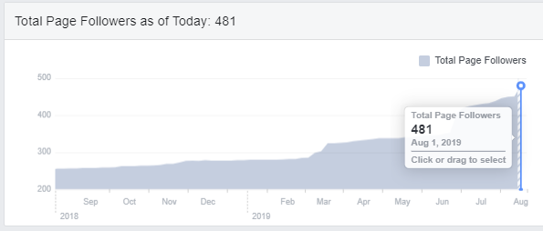
Facebook | Aug 2018 | July 2019 | Aug 2019
Followers | 254 | 428 | 481
Page Likes | 250 | 420 | 443

July popular posts:
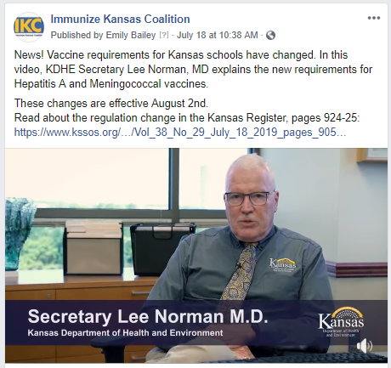
7/18/19 “News! Vaccine requirements for Kansas schools have changed. In this video, KDHE Secretary Lee Norman, MD explains the new requirements for Hepatitis A and Meningococcal vaccines. These changes are effective August 2nd. Read about the regulation change in the Kansas Register, pages 924-25: https://www.kssos.org/…/Vol_38_No_29_July_18_2019_pages_905…”
Reach | 3,678
Shares | 45
👍 Likes | 81

7/15/19 “School supplies, check. New clothes, check. Vaccines? Have you crossed vaccines off your kids’ back-to-school checklist? All preteens need three shots before they go back-to-school to be protected from serious, sometimes deadly, diseases.”
Reach | 2,014
Shares | 23
👍 Likes | 28

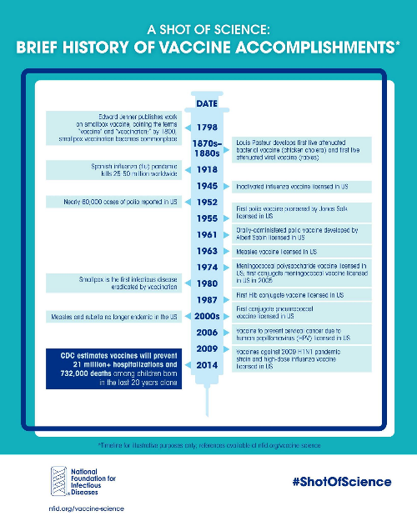
7/9/19 “#Vaccines are among the most significant achievements in public health. Between 1924-2013, childhood vaccinations prevented over 100 million cases of serious disease - National Foundation for Infectious Diseases http://ow.ly/zyfh30oVmWC.”
Reach | 1,010
Shares | 10
👍 Likes | 26

Twitter: @ImmKSCoalition, https://twitter.com/ImmKSCoalition
Twitter | July 1 | August 5
Followers | 83 | 90 (+7)
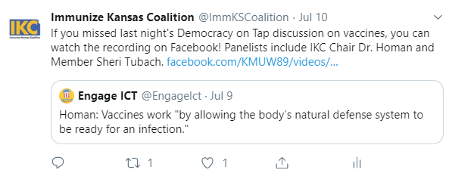
July Top Tweets

501 Total Impressions, 1 Total Retweets, 1 Total Likes “If you missed last night's Democracy on Tap discussion on vaccines, you can watch the recording on Facebook! Panelists include IKC Chair Dr. Homan and Member Sheri Tubach. https://t.co/pDOO93S0JI?amp=1”

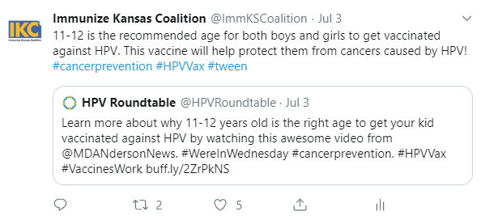
789 Total Impressions, 2 Total Retweets, 5 Total Likes “11-12 is the recommended age for both boys and girls to get vaccinated against HPV. This vaccine will help protect them from cancers caused by HPV! #cancerprevention #HPVVax #tween”

IKC Youtube https://www.youtube.com/channel/UCpMFLZm1NYIIzi97yH4UbPA

HPV Videos
Video | YouTube | Facebook | IKC Website
A Strong Recommendation for the HPV Vaccine | 257 views | 5,297 reached  (2 posts) | 235 total unique page views from IKC website
A Strong Recommendation for the HPV Vaccine - PSA | 61 views | -
HPV Vaccine: A strong provider recommendation matters | 101 views | 588 reached  (1 post)

IKC LinkedIn www.linkedin.com/company/immunize-kansas-coalition/ (Launched 5/3/18)
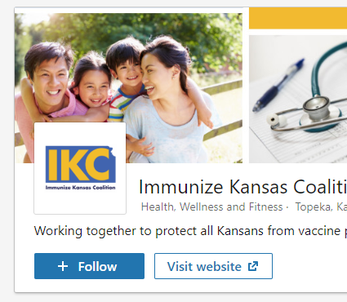
User: Immunize Kansas Coalition
LinkedIn | July 1 | August 5
Followers | 12 | 14 (+2)

Follow IKC on LinkedIn by going to https://www.linkedin.com/company/immunize-kansas-coalition and clicking the blue +Follow button
Add IKC to Your LinkedIn Profile: To add IKC to your experience, Go to your profile, Click “Add Profile Section” under your name, Choose “Add Volunteer Experience.”
This comment, though not greyed out, is still hidden because it was made to a hidden post.

